Dear student! We’re glad to welcome you on «Advanced Network & Cloud Security» section of International Summer School based on TEMPUS ENGENSEC project in Saint-Petersburg!
During this section you would have practice in series of tasks, connected with Cisco equipment (hardware and virtual), network programmability, overlay networks, virtualization and cloud networking. Final result of your work for today will be configured topology, where all the tasks, requested by your customer have been done. Team that will finish all the tasks of this practice laboratory first – would win.
Good luck!

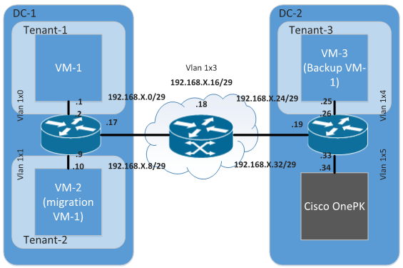

Picture 1. Given Topology

Story.
You’re network engineer with quite good practice experience in networking, skilled enough to create and troubleshoot networks in medium-size Company (CCNA RS or CompTIA Network certified), you also be able to configure Linux OS, having practice experience with BASH scripting, knowing basic programming principles, using one of the popular programming languages like C, Java or Python. Also after some training courses you got enough theoretical things on what’s going on in advanced networking, including VXLAN overlay networks, network programmability, using Cisco ONE PK solution and basic fundamental skills in virtualization.
You’re members of operations shift at Cloud Service Provider. You’re drinking your coffee, chatting and having no idea that day ago one customer company extended their contract with additional services:
- They bought new tenancy with enhanced resources
- They bought additional resources of your DC in different country (for backups at geographically diverse place)
- They bought DC interconnect option between sites (local and remote DCs)
Thereafter the Customer have opened a ticket and this task has been distributed to your team. Ticket objectives:
- You should install Linux VM, based on .iso.
- You should move one VM from old customer’s tenancy to new one
- You should make typical L2 connectivity service between customer’s tenancies in different DC which are managed by your team
It might will be just a pretty typical job with application of prepared bunch of templates in your cloud services platform, but you’ve got an error message from cloud orchestration management console. All orchestration and cloud services works well, but you are experiencing unreachability of management console. You‘ve opened a ticket in vendor technical support and you are waiting for resolution, but Cloud Service Provider have strict SLA to the Customer and your team should close customer’s ticket using half-manual automation methods.
Please have a look at the picture to understand the topology view of task.

Task 0
You have deployed an CSR virtual router from template, but this template gives you no access to traditional CLI. DC orchestration model uses network automation and programmability features of virtualized networking equipment. You have reachable meed-end OnePK controller in infrastructure but you can’t use orchestration templates, so you have to use direct north-bound API of OnePK framework to complete your task.
Task 1.
You’re are technical support team of data center. Your customer request you to install virtual machine on OS Linux, but your authorization rights in data center are limited and you could install virtual machines only on a specific tenant of the data center.
Task 2.
Move existed customers VM from old tenancy to new one. According to this you need to migrate VM to another tenant, where you have enough resources. For this you need to configure:
- migrate your VM to another tenant;
- give your VM more resources that are needed by your customer.
Task 3.
You need to create an overlay network (VXLAN based) above existed DC interconnect between local DC1 and remote DC2.
Task 4.
Check the completion with doing of customers VM backup from new tenant at DC1 to VM located in remote DC 2.

